**Saroni Global Business Pvt. Ltd.**

Head office: 2nd Floor, Ganesh Market, LIC Buiding, Near UCO Bank, Narengi Tiniali, Guwahati, Assam, India, PIN: 781026

Mob: +91-7002329489 / 9859931042

Email: trade@saroniglobal.com

PARBOILED RICE

**Long Grain Parboiled (IR 64/Ratna Rice)**

|  |  |
| --- | --- |
| Specification | |
| Silky and Sortex | |
| Broken Percentage | 5% |
| Grain Length | 5.8mm-6.2mm |
| Moisture | Below 14% |
| Colour | Pale yellow to White |

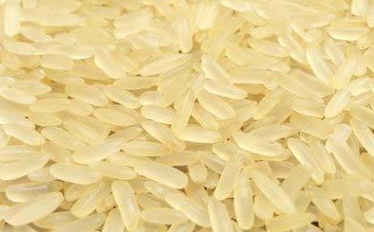

**Short Grain Parboiled (Swarna Rice)**

|  |  |
| --- | --- |
| Specification | |
| Silky and Sortex | |
| Broken Percentage | 5% |
| Grain Length | 5.8mm-6.2mm |
| Moisture | Below 14% |
| Colour | Pale yellow to White |

|  |  |
| --- | --- |
| **Specification** | |
| **Silky and Sortex** | |
| **Broken Percentage** | **5%** |
| **Grain Length** | **5.0 mm - 5.7 5mm** |
| **Moisture** | **Below 14%** |
| **Colour** | **Pale yellow to White** |

|  |  |
| --- | --- |
| Specification | |
| Silky and Sortex | |
| Broken Percentage | 5% |
| Grain Length | 5.8mm-6.2mm |
| Moisture | Below 14% |
| Colour | Pale yellow to White |

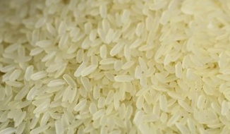

**Sona Masuri Rice**

|  |  |
| --- | --- |
| **Specifications** | |
| **Silky and Sortex** | |
| **Broken Percentage** | **5%** |
| **Grain Length** | **5 mm - 5.2 mm** |
| **Moisture** | **Below 14%** |
| **Colour** | **White** |

**Miniket Rice**

|  |  |
| --- | --- |
| **Specifications** | |
| **Silky and Sortex** | |
| **Broken Percentage** | **5%** |
| **Grain Length** | **6.0 mm – 6.5 mm** |
| **Moisture** | **Below 14%** |
| **Colour** | **White** |

**Banskathi Rice**

|  |  |
| --- | --- |
| **Specifications** | |
| **Silky and Sortex** | |
| **Broken Percentage** | **5%** |
| **Grain Length** | **7.30 mm – 8.10 mm** |
| **Moisture** | **Below 14%** |
| **Colour** | **White** |

**100 % Grader Broken Parboiled**

|  |  |
| --- | --- |
| **Specifications** | |
| **Broken Percentage** | **100%** |
| **Grain Length** | **NA** |
| **Moisture** | **Below 14%** |
| **Colour** | **Pale Yellow to White** |

WHITE (RAW) RICE

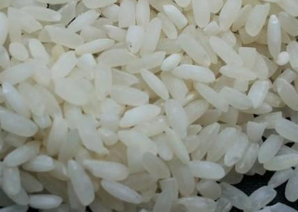**Sona Masuri Raw**

|  |  |
| --- | --- |
| **Specifications** | |
| **Silky and Sortex** | |
| **Broken Percentage** | **5%** |
| **Grain Length** | **5 mm – 5.2 mm** |
| **Moisture** | **Below 14%** |
| **Colour** | **White** |

**Jeera-Kasala /Gobindobhog Raw**

|  |  |
| --- | --- |
| **Specifications** | |
| **Broken** | **3%** |
| **Moisture** | **10%** |
| **Chalky** | **Nil** |
| **FM** | **Nil** |
| **DD** | **0.20** |

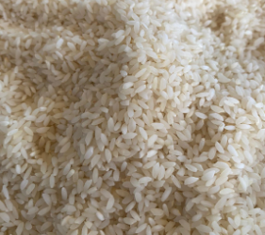

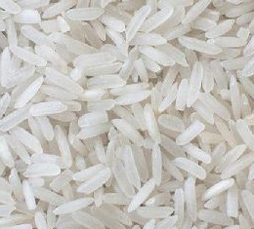**Long Grain Raw (IR 64 / Ratna Rice)**

|  |  |
| --- | --- |
| **Specifications** | |
| **Silky and Sortex** | |
| **Broken Pecentage** | **5%** |
| **Grain length** | **5.8 mm – 6.2 mm** |
| **Moisture** | **Below 14%** |
| **Colour** | **White** |

**Short Grain Raw (Swarna Rice)**

|  |  |
| --- | --- |
| **Specifications** | |
| **Silky and Sortex** | |
| **Broken Percentage** | **5%** |
| **Grain Length** | **5 mm – 5.75 mm** |
| **Moisture** | **Below 14%** |
| **Colour** | **White** |

|  |  |
| --- | --- |
| **Specifications** | |
| **Broken Pecentage** | **100%** |
| **Grain Length** | **NA** |
| **Moisture** | **Below 14%** |
| **Colour** | **White** |

**100% Grader Broken Raw**



